A Judge’s Guide to the Supreme Court’s Access to Justice website
www.JusticeForAllTN.com

You can go directly to the website or link to it from the AOC site, www.tncourts.gov.
From the AOC site, go to Programs then Access to Justice or Self-Help Center to link to the website.

You can point self-represented litigants to the site for helpful information like:
- Brief summary of the court system in Tennessee
- Glossary of legal terms
- How to find a lawyer
  - Qualifying for legal aid and how to find the local legal aid office
  - A link to www.OnlineTNJustice.org where they can email questions to an attorney
  - Lawyer referral services
- Guidance on how to represent themselves in court
- Court forms
  - Plain language divorce forms
  - Parenting Plan
  - Order of Protection
  - Forms related to mediation and parent education
  - Links to forms developed by legal aid groups
  - Plain language civil forms for use in general sessions court
- Interactive map where they can click on their county and find contact information for local resources
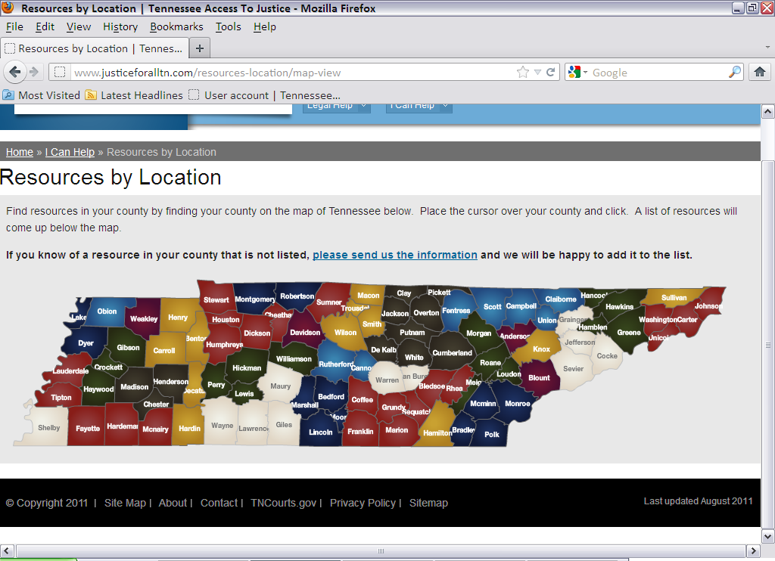
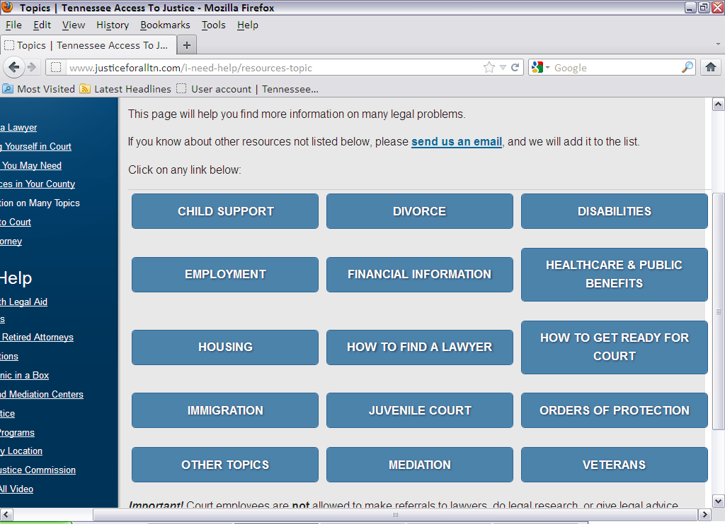
- General information on various topics

- Information about Mediation
- Information on the Tennessee Faith & Justice Alliance

There is also information for attorneys, mediators, and other volunteers who want to donate their time to do pro bono or reduced fee work.

